A). Aggregate Tax (GST+TCS)

For Order (Purchase / Sales) related.

* Create a Singular Tax Code for TCS.

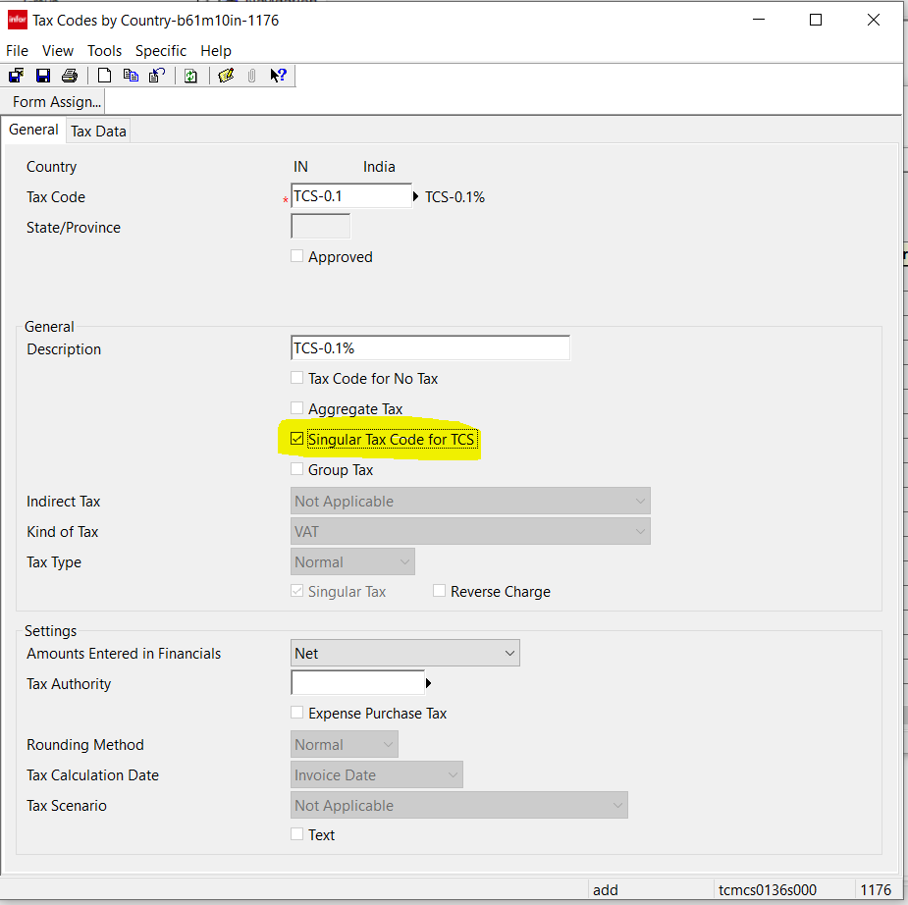

Singular Tax for CGST.

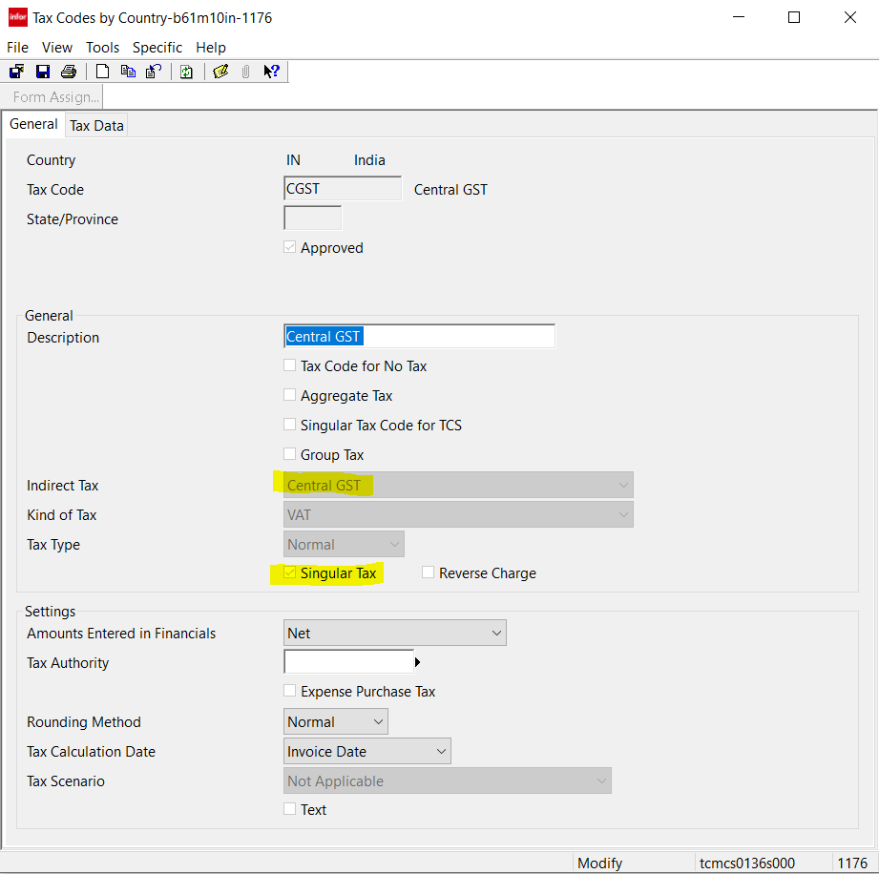

Singular Tax for SGST.

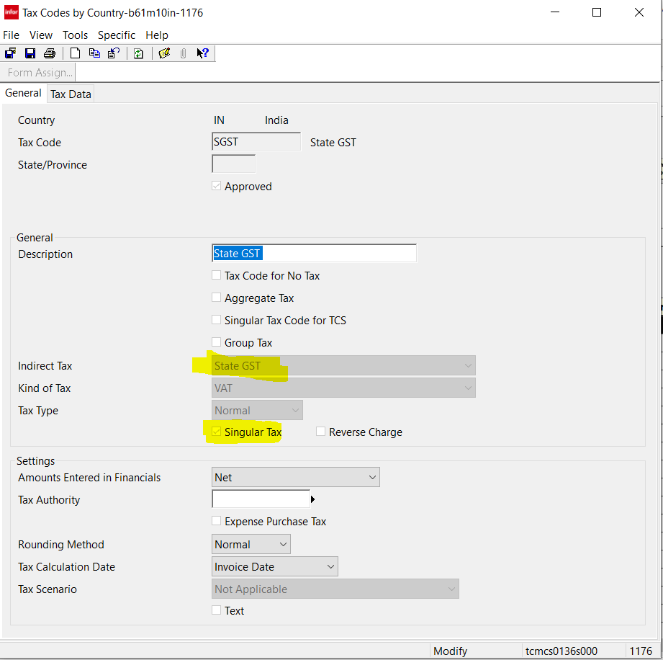

Create an Aggregate Tax Code and assign GST (CGST+SGST or IGST) + TCS tax codes.

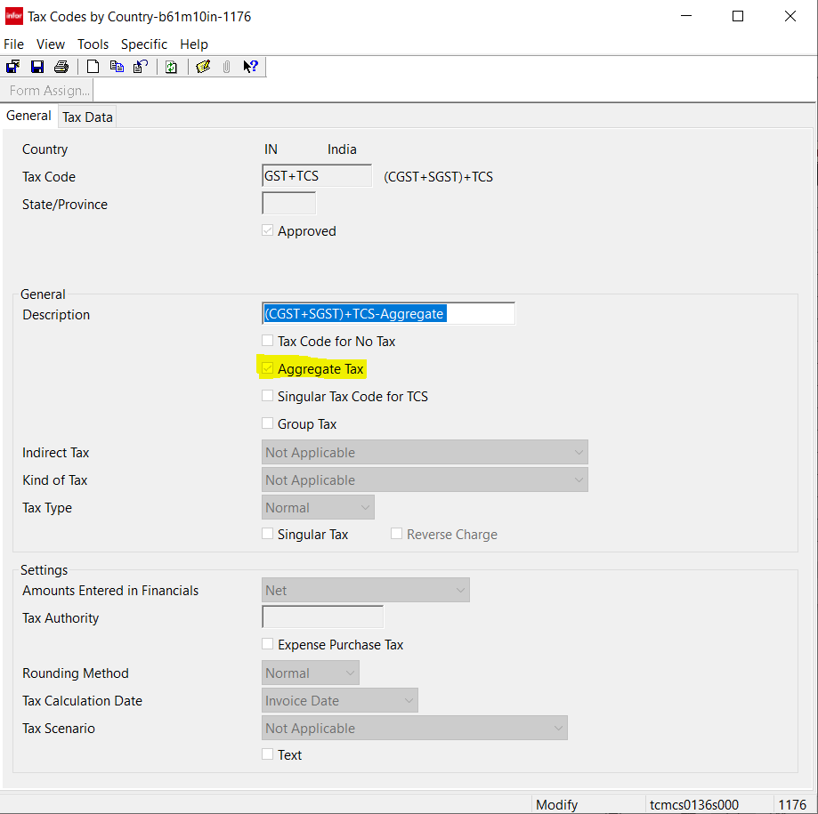

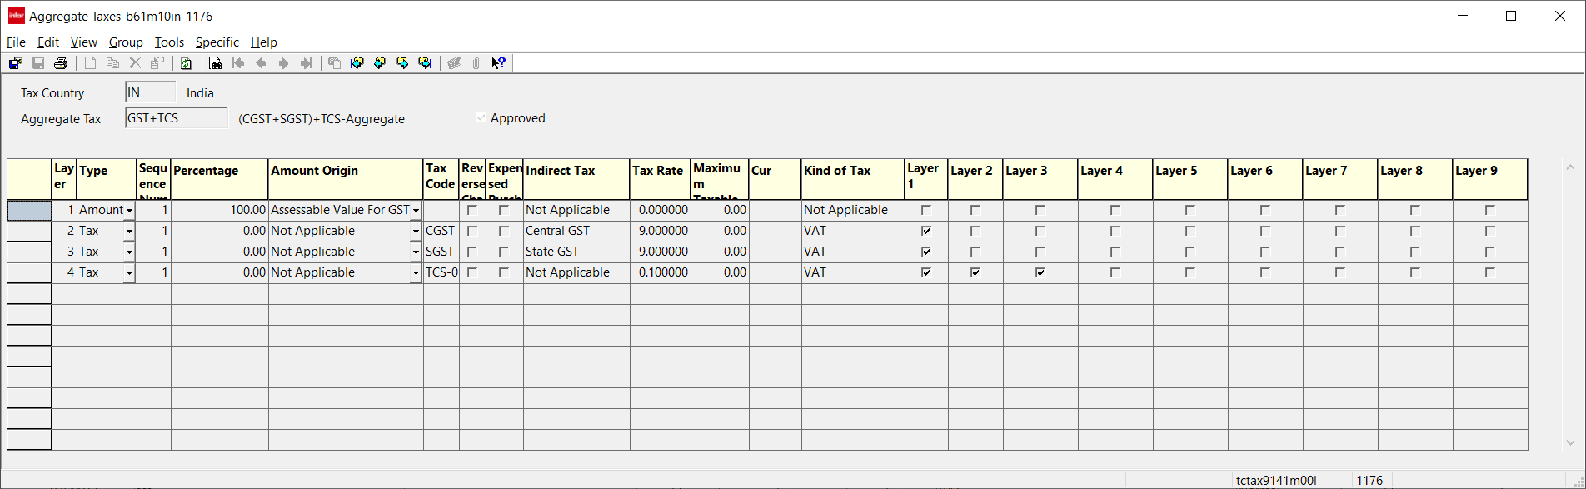

* Create a Purchase Order and assign this Aggregate Tax code.
* Process the Logistics activity.
* Post the Integration Transactions.
* During invoicing the tax line populates in ‘Invoice Tax Lines’. For TCS line you need to define ‘Tax Registration Sequence (Own) as PAN category. After that Create Posting.
* Match & Approve the Purchase Invoice.
* For claiming TCS you need to execute the session ‘Process Order Tax Details (tfacp9235m00l)’ for Purchase side.
* To check the TCS data print the session ‘Print TCS Register (tfacr2403m00l)’. Purchase Invoice will appear in this register.
* In case of Sales – in ‘Print Tax Invoice’ TCS will not show as this report is only for GST. In Commercial Invoice it will display TCS amount.

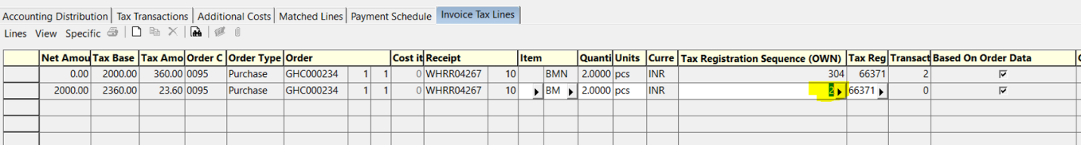



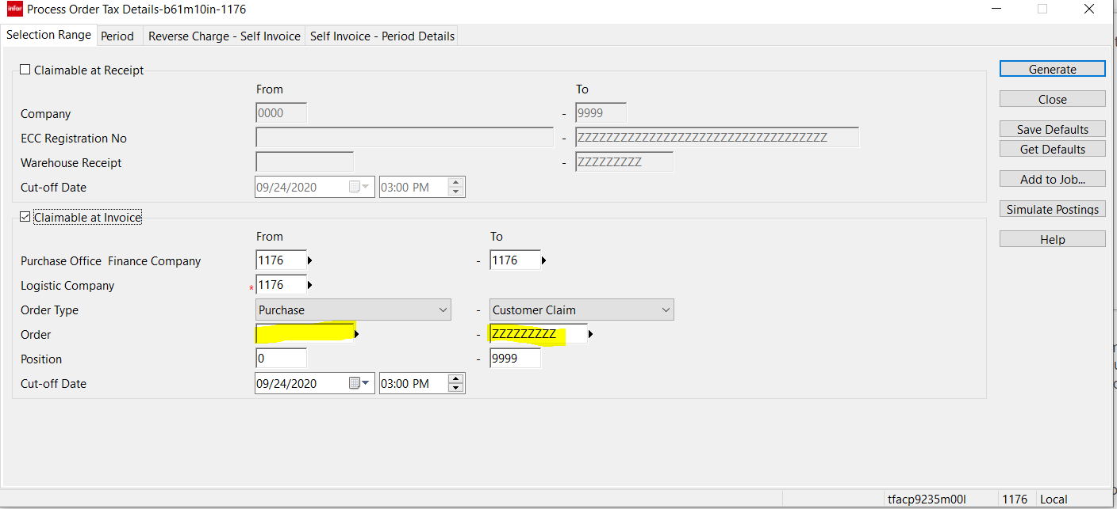

B). Multiple Tax Code (GST+TCS): -

For cost related transaction.

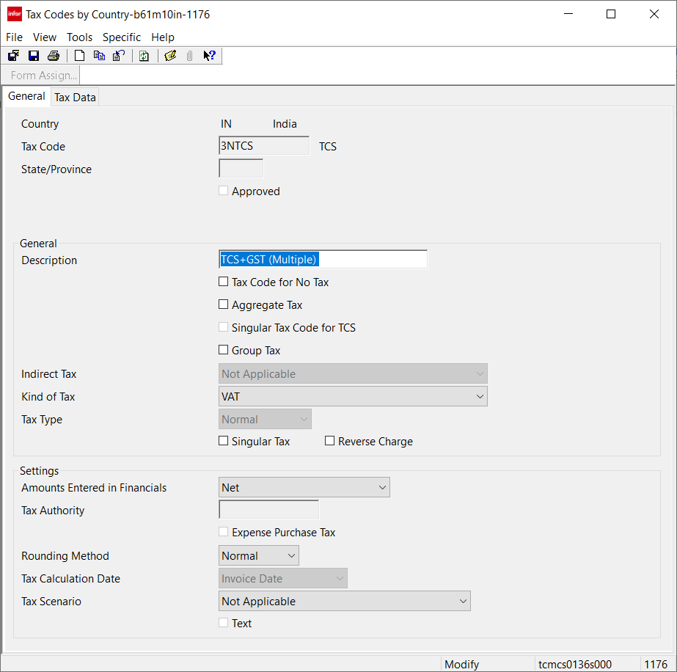

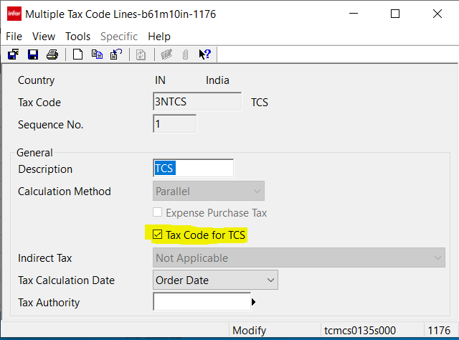

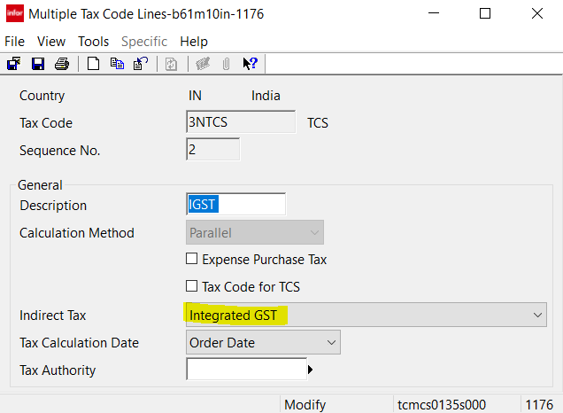

* Create a Cost Purchase Invoice and assign this Multiple Tax code.
* Finalize the batch.
* For Cost Invoice, TCS ledger will pick end account i.e. ‘Purchase Tax a/c’, therefore no need to run Process Order Tax Details (tfacp9235m00l).

Note: -

In Group Tax code, TCS cannot be used as twice we cannot assign VAT kind of tax. TCS tax code is having Kind of Tax = VAT and GST tax is also VAT type. For this you've to use Multiple Tax.

In Unallocated Receipt we should not use TCS tax code. In Advance Receipt we can assign it. We can assign only singular TCS code.

TCS is applicable on Goods and not on Services.